Connect to Cerberus and select the system you want to deploy
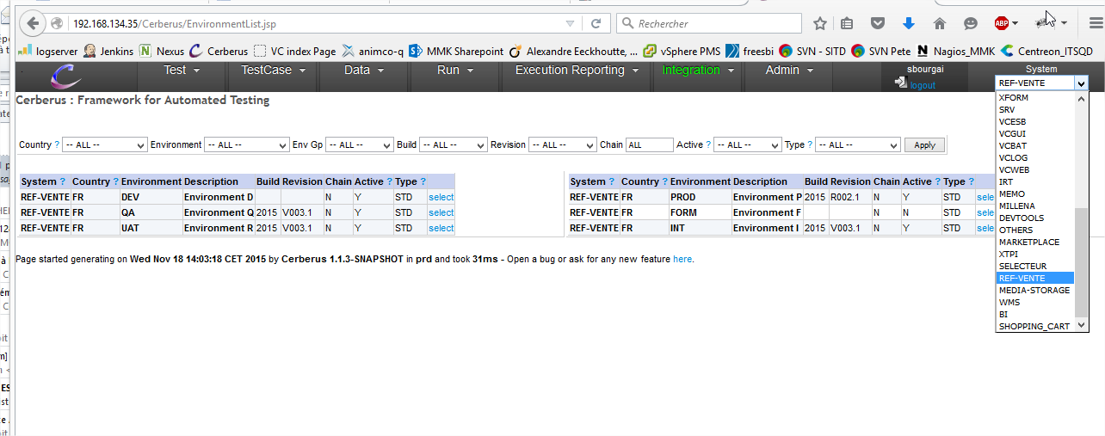

Then, go to menu ‘integration > environments’
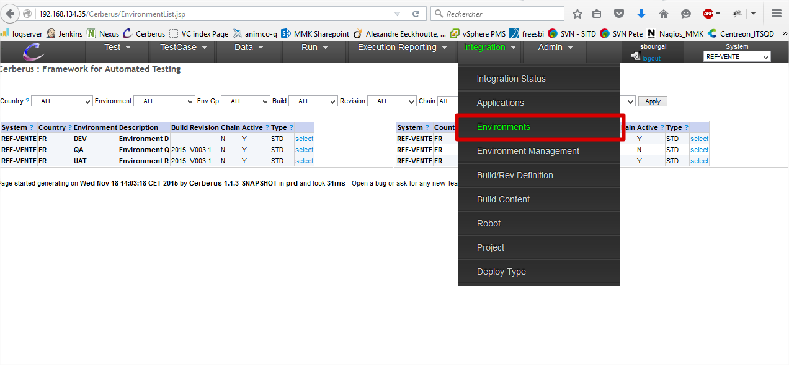

You select the environment you’ve been requested in the MOSS ticket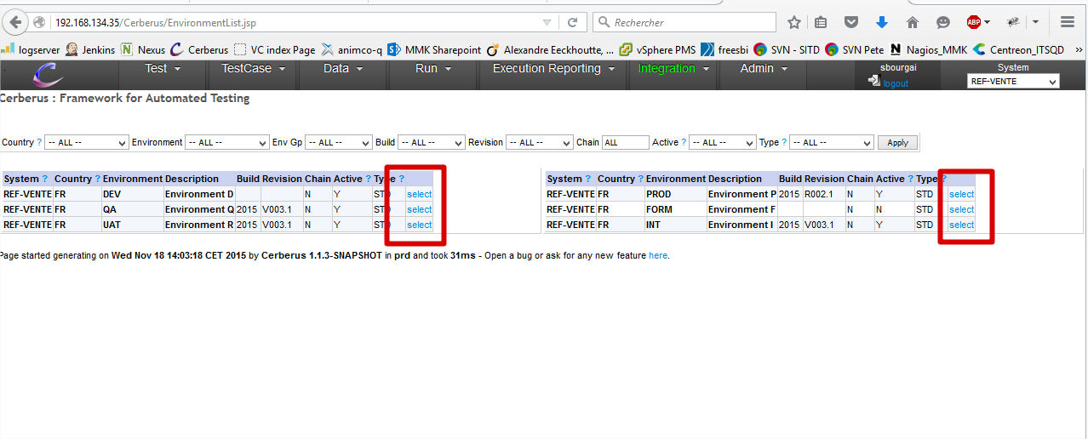

- Check every informations :
  - System
  - Country
  - Environment
  - Is the env currently active ?
Note : the environment will be “not active” during the deploy, so no test will run during a deploy.
When you’re ready to start:
- Click the ‘disable environment’ button
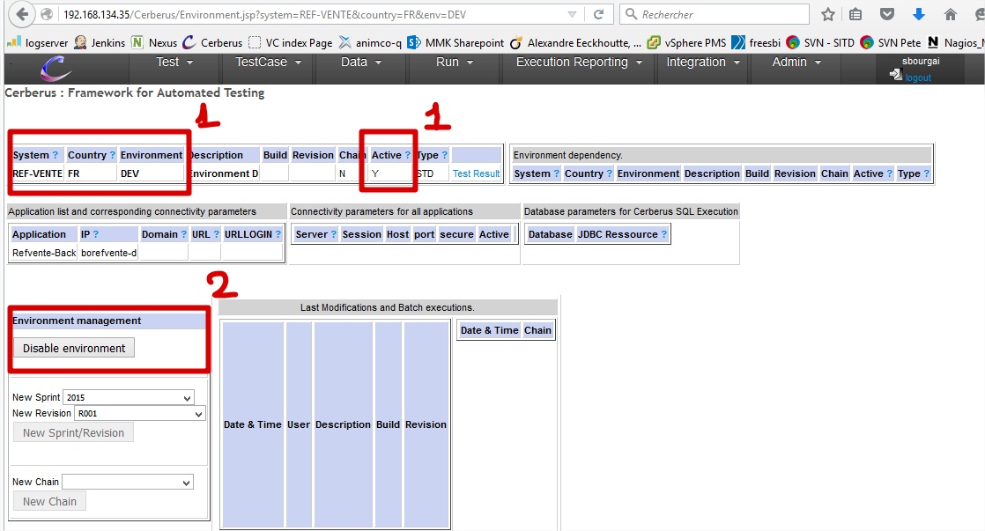

In the following page you see the mail sent to the people working on the application to warn’em the environment is being upgraded
Check :
- Env, application, system, current version (you have deployed nothing yet)
- And click the ‘validate and send notification’ button 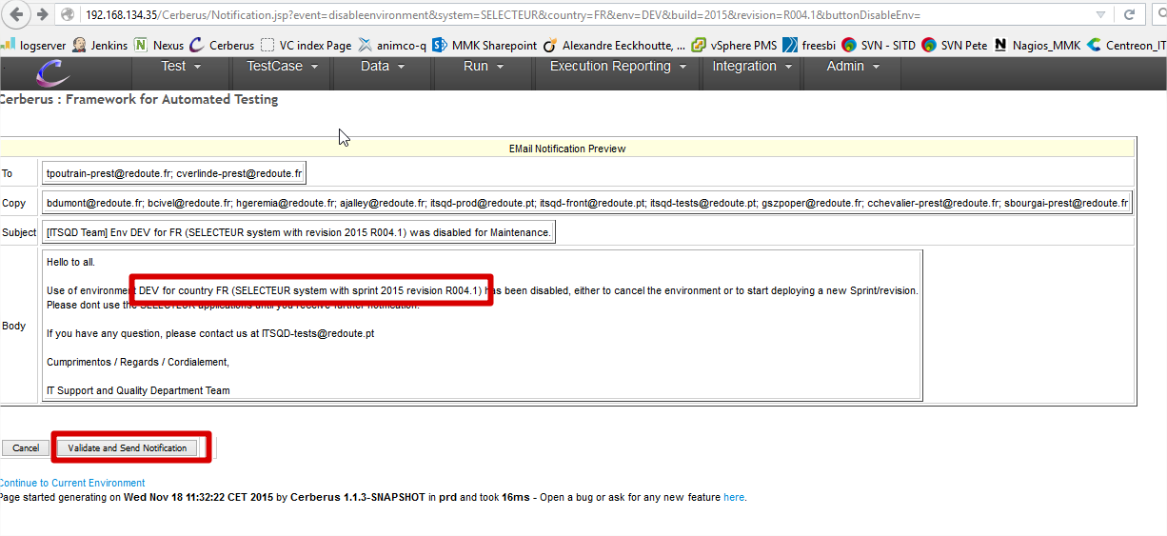

Check again :
- Env, application, system, current version (you have deployed nothing yet)
- Check the list of upgrades embedded in the new version (this list cannot be empty)
And you can start the deploy
- If you have an automated deploy application you’ll have a link to trigger the deploy
Otherwise, a link to the delivery is shown. Then, refer to the deploy procedure you have about it
- In case of an automated deploy, check the Jenkins deploy log
Finalise the deploy
- Once every deploy is done, click on the ‘validate and send notification’ button to warn everyone the deploy is done
